**17.DevOps-B24-Terraform-Part-3**

--- **note** – so far, we talked about resources and data sources. In this session we will talk about dependencies, terraform lifecycle.

**Terraform lifecycle policies**

--- **Reference** - <https://www.terraform.io/language/meta-arguments/lifecycle>

--- in terraform lifecycle policies, we have [**create_before_destroy**](https://www.terraform.io/language/meta-arguments/lifecycle#create_before_destroy), **prevent_destroy**, **ignore_changes**.

--- **note** – there are 2 types of dependencies in terraform

1. Implicit dependencies
2. Explicit dependencies

--- **1. Implicit dependencies** – terraform will find on its own.

--- **2. Explicit dependencies** – here we need to mention the dependencies.

**depends_on**

--- **depends_on** – we can use this parameter to create a resource after other resource. We can explicitly mention the dependencies of one resource with another.

depends_on = [ resource.name]

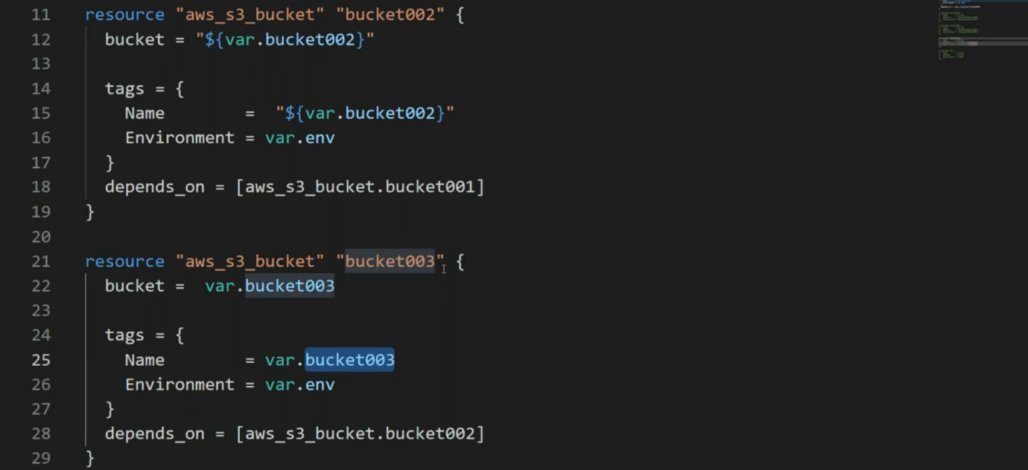

--- **note** – below executes after the 1st resource.

**define variable in terraform**

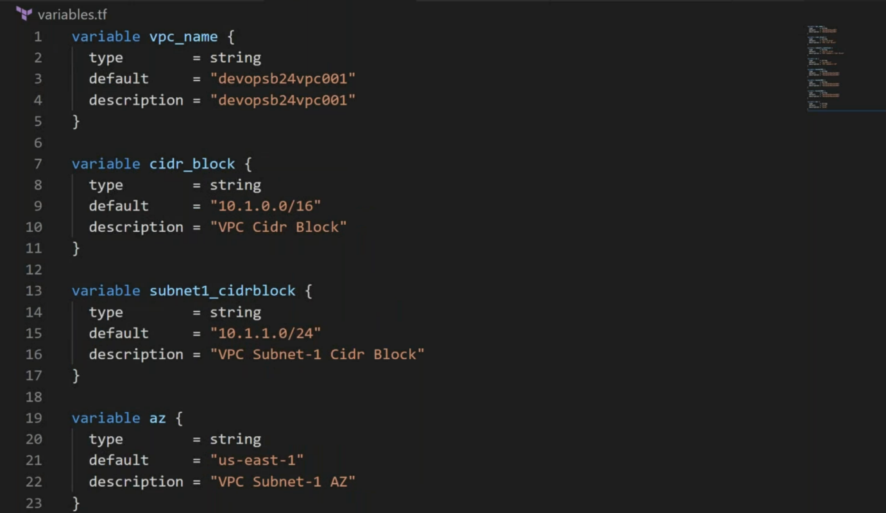

--- **variable** – variable declaration file.

--- terraform.tfvars/*.auto.tfvars/*.tfvars – variable definition file.

--- **how do I create 4 tfvars in terraform manifests...?**

Any file end with .auto.tfvars, this way we can create 4 tfvars files.

**create_before_destroy (Replace the vpc)**

--- **note** - you want to replace the vpc, normally what happened is, terraform will destroy the vpc and will crate the new vpc but you do not want that. You want terraform to create a new vpc before destroying existed vpc.

--- **eg**

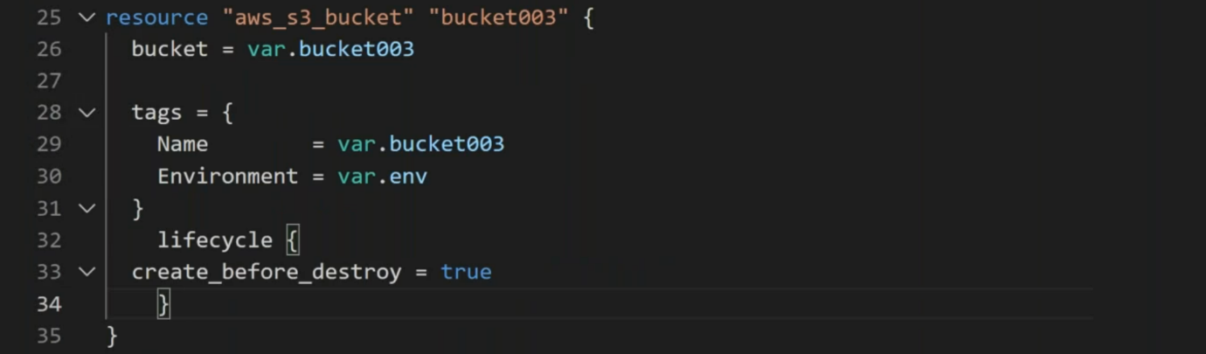

--- **lifecycle {**

**create_before_destroy = true**

**}**

**Difference between +/- and -/+**



--- -/+ - minus means destroying and plus means creating.

--- **note** – here I am trying to replace the older bucket with new bucket.

**prevent_destroy**

--- we have some high priority servers. if you change key in terraform manifests and executed terraform apply then the terraform will destroy existed server and recreate the server with give key.

--- you do not want the terraform to destroy the instance then we use this parameter.

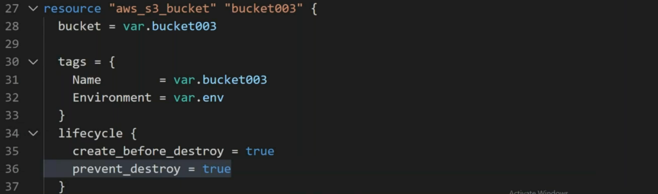

**ignore_changes**

--- **scenario** – sometime we adding security rules form aws console and you want terraform to ignore those changes then we will use ignore_changes.

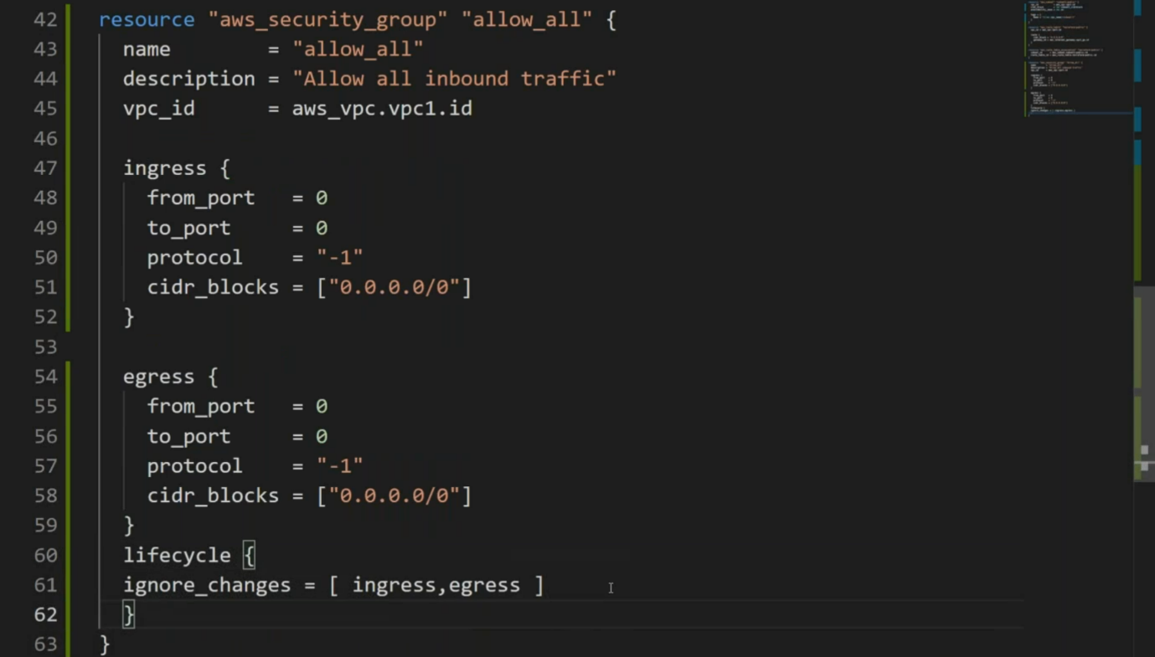

--- **note** – same you want to ignore while creating other resources.

